|  |
| --- |
| FlyAway  (An Airline Booking Portal)  Screenshot |

|  |  |
| --- | --- |
| Author | Aman Kumar |
| Purpose | Project Screenshot |
| Date | 28/02/2022 |
| Version | 1.0 |

Version History:

1. **Homepage**

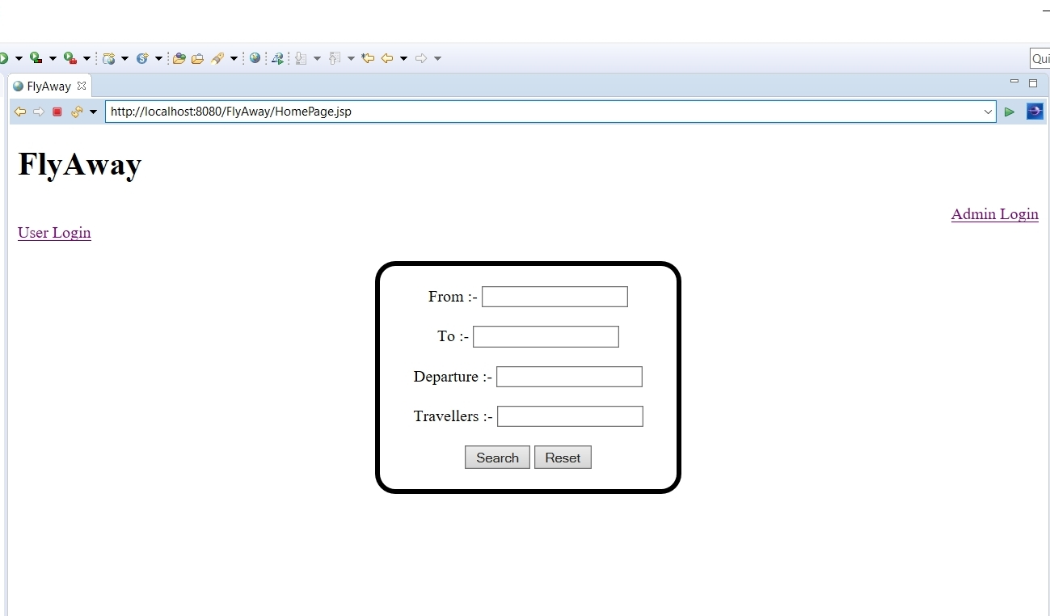

1. **User Login Page**

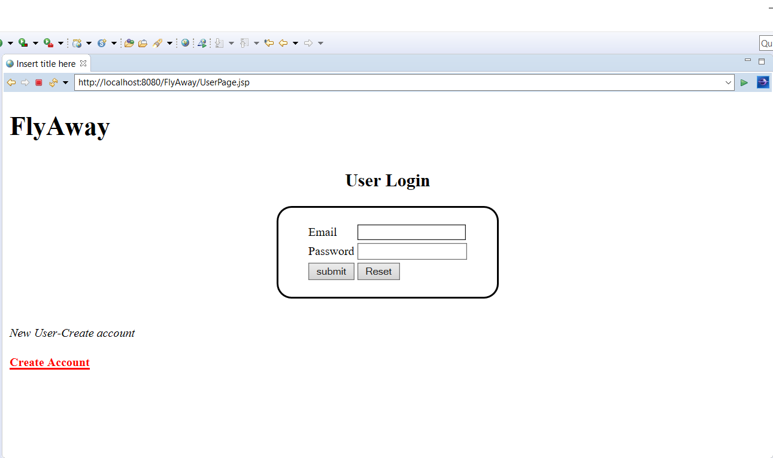

1. **User will enter login credentials**

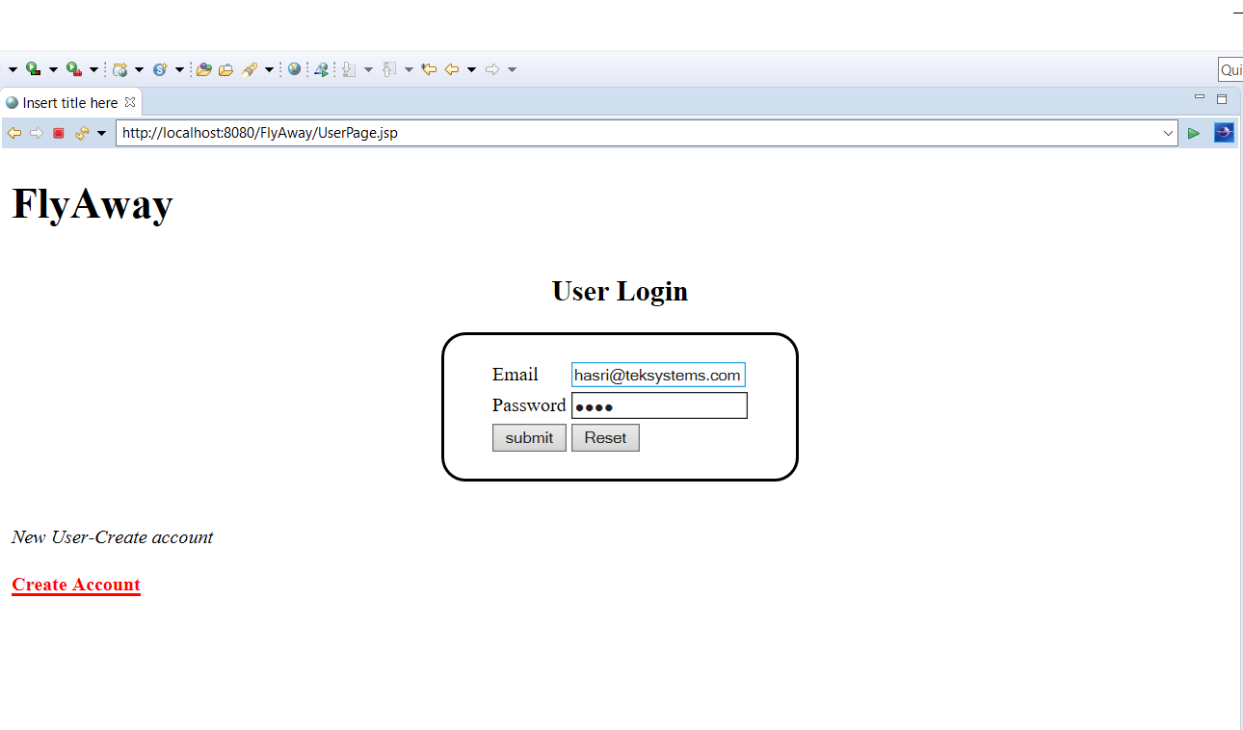

1. **User Home page**



1. **User will entered flight search details**

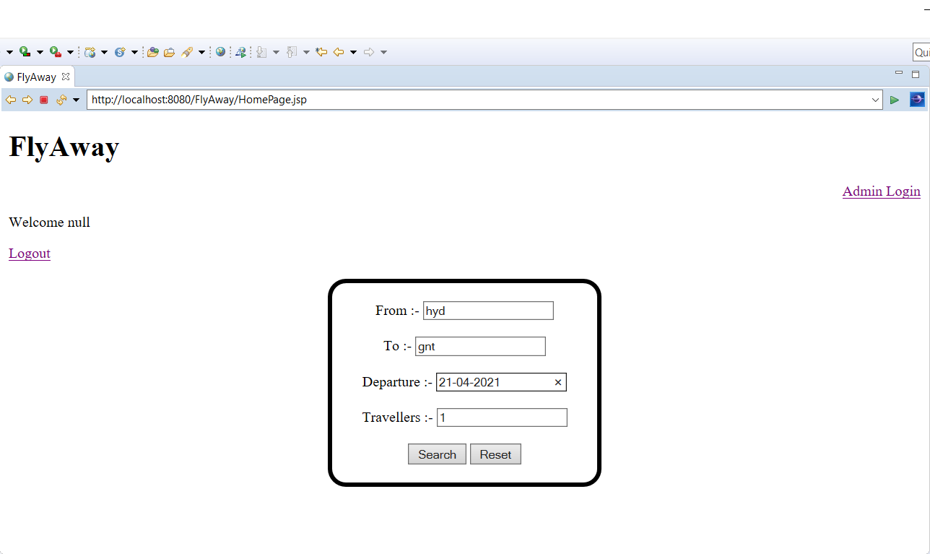

1. **Available flights**

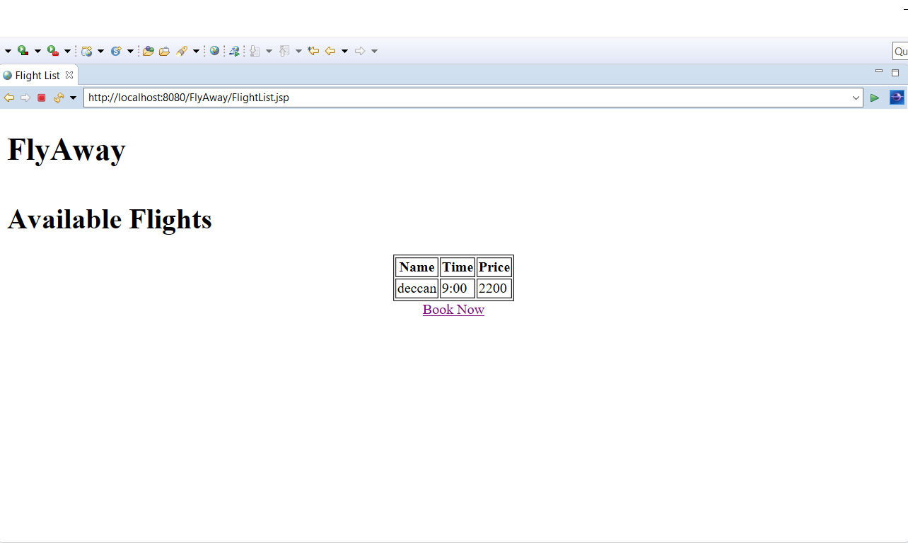

1. **Booking successful**

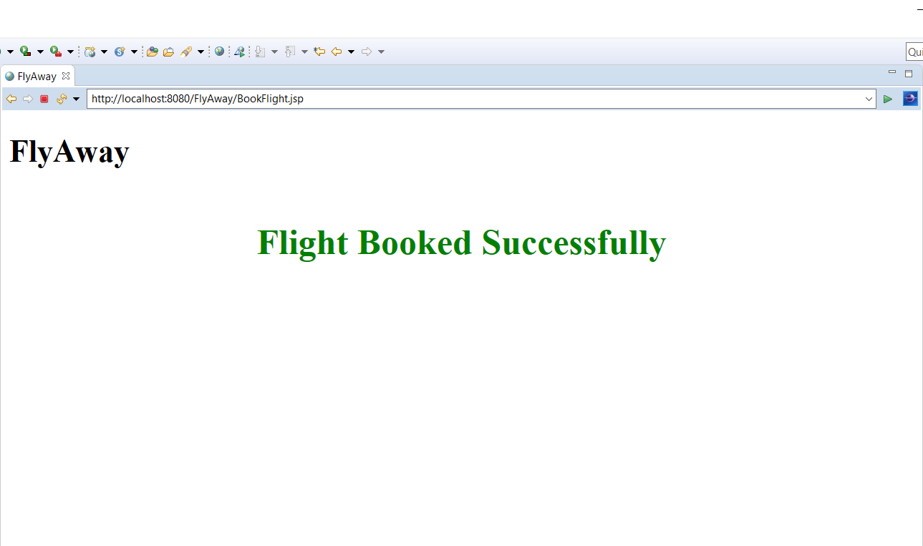

1. **Admin login page**

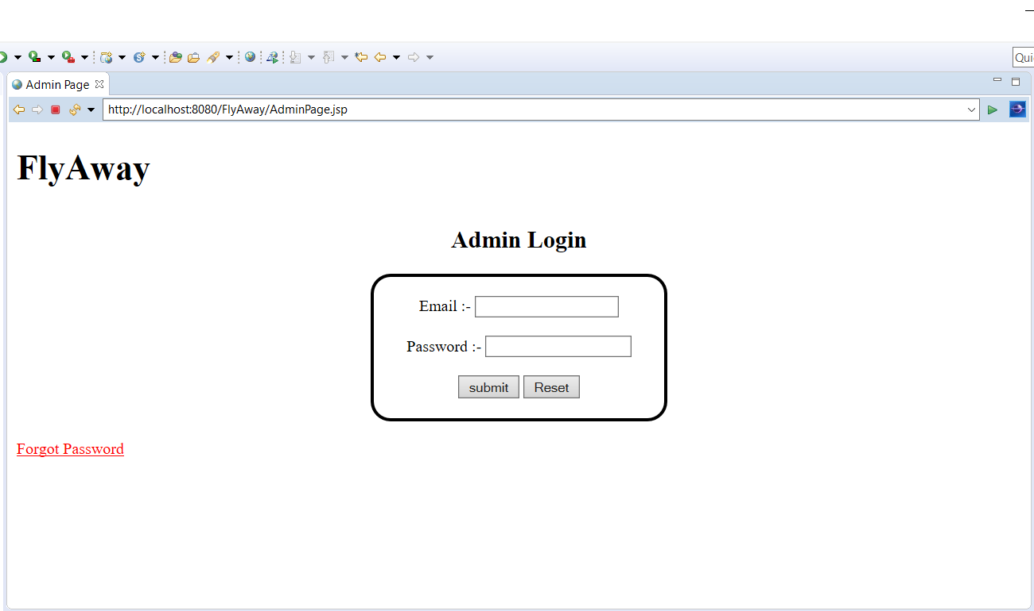

1. **Admin home page**

